Smart Columbus Overview: Electric Vehicle Supply Equipment
Electric Vehicle Supply Equipment (EVSE), also known as electric vehicle (EV) “charging stations”, provide all the equipment necessary to deliver electrical energy to an electric vehicle’s battery. There are three primary types of EVSE: AC Level 1, AC Level 2, and DC Fast Charging. For AC Levels 1 and 2, alternating current is provided to the vehicle’s onboard charger, which converts the electricity to the direct current required to charge batteries. DC Fast charging provides direct current immediately to the vehicle’s battery. Level 1 and 2 Charging stations use the J1772 charging connector, while Tesla’s charging stations use their own propriety connector to connect to the vehicle. For DC Fast Charging, nearly all vehicles can accept either the CCS Combo standard or the Chademo standard. Tesla offers adapters to allow its cars to connect to all other connectors. See below for examples of each charging station.
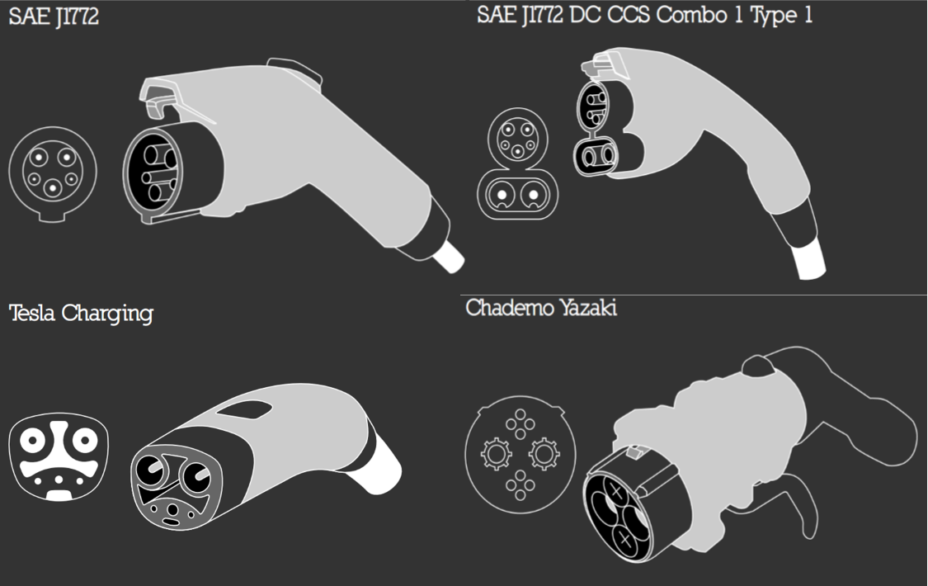
EVSE units are available in different amperage ratings which correlate to charging power. The time it takes to charge depends on the level of charge in the battery, the power coming from the EVSE, and the rate a vehicle can accept power, which may be lower than the power supplied from the EVSE. The table below provides an overview of EVSE charging times and supply power.
Charging Level | Vehicle Range Added per Charging Time and Power | Supply Power | Applicable Connector(s)
Level 1 | 4 mi/hour @ 1.4kW  6 mi/hour @ 1.9kW | 120VAC/20A  (12-16A continuous) | J1772  Tesla
Level 2 | 10 mi/hour @ 3.4kW  20 mi/hour @ 6.6kW  60 mi/hour @ 19.2 kW | 208/240VAC/20-100A  (16-80A continuous) | J1772  Tesla
DC Fast Charging | 24mi/20 minutes @ 24kw  50mi/20 minutes @50kW  90mi/20 minutes @ 90kW | 208/240VAC 3-phase  (input current proportional to  output power; ~20-400A AC) | Chademo  CCS Combo  Tesla Supercharger

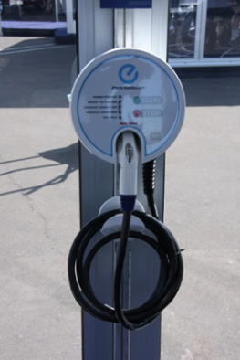
EVSE Features and Options
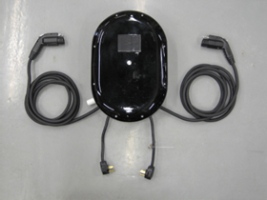
EVSE equipment varies dramatically in costs, designs, and features. Units are typically available in either wall mounted or pedestal mounted varieties. Pedestal mounted units cost about $500-700 more than a wall unit due to associated costs of the pedestal, as well as additional construction costs of the pedestal installation. Single port EVSE units provide charging for one vehicle at a time, and are cheaper than EVSE units with multiple ports. It is important to note that both the unit cost and the installation cost are less expensive on a per-port basis for multiple port units.
A basic EVSE unit will simply provide electricity to the vehicle, with an indicator light to show when the vehicle has started or finished charging. There are numerous options and capabilities available for networked units, which are connected to the internet through a cable or wireless technology. There are a variety of networked EVSE available in the marketplace, and there is also the option to add an aftermarket module to a non-networked EVSE that enables it with various networked capabilities. Without EVSE, some electric vehicles do have some networking capabilities through onboard software, such as scheduling charging times, managing charging rates, and even communicate with the grid, when possible.
Networked EVSE
Networked, or “Smart” charging technology, provides the ability to access the EVSE remotely at any time for utilization of the following features, in descending order of technological advancement:
Authentication/Access
- Basic lock and key entry
- Digital Access Features:
  - Site host can require Passcode or credentials
  - Users must connect through their Smartphone via bluetooth or WiFi
- Digital access through network:
  - RFID
  - Can require Vendor / organization card
  - Access through Mobile app

Marketing/Educational Capabilities:
- Site owner can promote their company or educate around EVSE usage through videos and advertisements either in mobile app or on EVSE equipment screen, enabling revenue stream from advertisement
Data access for host:
- Standalone units can monitor voltage and current of one or more EVSE units
- Manual (in-person download) or automatic (web/network publishing) data availability around EVSE usage
- Metering capability to track energy usage- can be per-unit or common to a bank of units
Data interaction with guest:
- EVSE provides guests with near real-time data availability from charger, typically accessible via mobile app
- May allow consumer to set preferences on rate of charge, completion time, pricing response etc.
Load Management:
- Local network connectivity allows building management to control power output of the system
- Can be used to optimize electrical infrastructure among a group of EVSE
- Could roll up to a building demand response program
Billing:
The site owner/operator can recoup costs through:
- Point of sale
  - RFID
  - Vendor/organization card
  - Credit card reader
- Mobile app integration
  - Vendor / organization / utility based billing integration
  - Paid access to a regional EVSE network (such as Chargepoint or Greenlots)
Grid integrated demand response:
- Energy Monitoring and Management: the site host or electrical utility can track the EVSE’s energy consumption and analyze usage to calculate GHG reductions. Smart charging is also necessary for optimizing energy load management to maximize charging during low demand periods, and minimize charging during peak hours.
- EVSE responds to regional and local grid needs and constraints as appropriate / configured
- Demand response can be structured through pricing tiers or utility driven equipment loading
See below for a diagram detailing a grid integrated networked EVSE system:
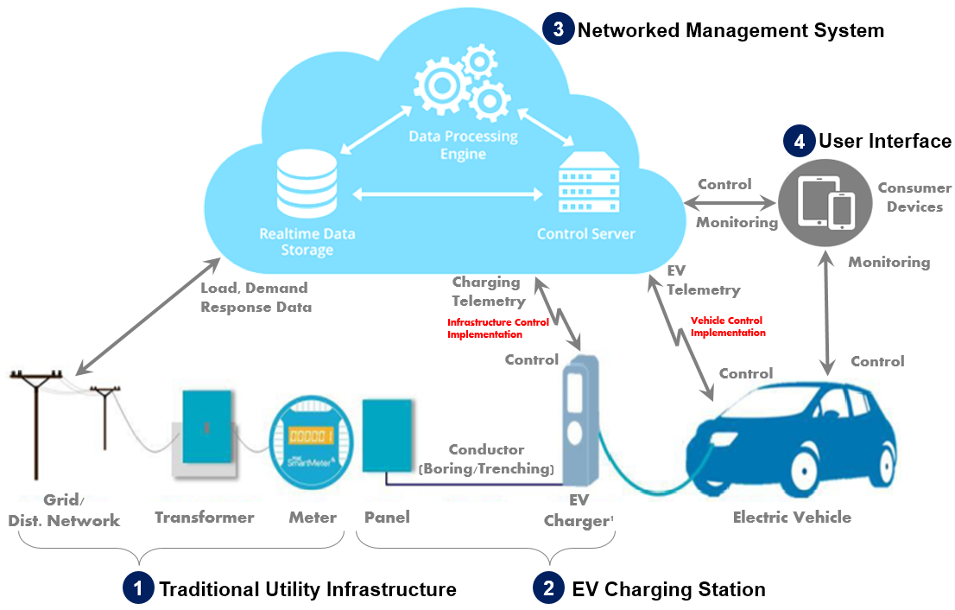
Networking Modules
There is also the option to add an aftermarket module to a non-networked EVSE that enables it with -various networked capabilities, including:
- Control over Authentication/Access
- Load control and metering
- Data Capture

These aftermarket modules allow for site hosts to purchase cheaper non-networked EVSE and later upgrade their capabilities. See image below for an example:
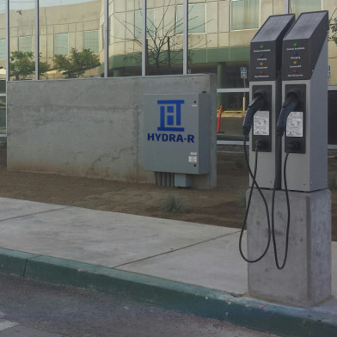

EVSE Costs and Considerations
Costs of EVSE units and installation vary significantly depending on the unit’s features, whether the unit is wall or pedestal mounted, and the details of the installation itself. Cost factors for installation include the distance between the unit and the electrical access point, whether the installation is a new build or retrofit, whether trenching is required, and whether or not the electrical service provides the following:
- A dedicated circuit for each EVSE unit on the electrical panel (in most cases).
- Sufficient electrical capacity from the utility connection to the electrical panel.
- Sufficient electrical capacity at the panel.
Costs of EVSE units increase the more features the unit contains. For installed EVSE, wall mounted units are cheaper than pedestal installations, and networked capabilities add cost as well. The below diagram shows an example of cost increasing with features.
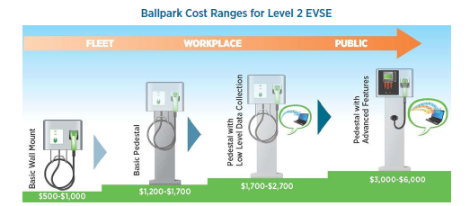

See table below for an overview and industry averages for EVSE unit cost and installation cost:
EVSE Type | Installation Cost Range (per unit) | EVSE Unit Cost Range (single port) | O&M Cost*
Level 1 | $0-$3,000  Source: US DOE 2016 Report | $300-$1,500 | -Maintenance: $100-300 lifetime  -Network fees: $100-900 annually
Level 2 | $600-$12,700  Source: EV Project, INL | $400-$6,500  (Networked Units cost up to 6,500) | -Maintenance: $300 lifetime  -Network fees: $100-900 annually
DCFC | $4,000-$51,000  Source: EV Project, INL | $10,000-$40,000 | -Maintenance: $1,000-2,000 annually  -Network fees: $100-900 annually
*Operation and Maintenance costs varies significantly based on equipment and features. Regular maintenance is not required for basic Level 1 and 2 EVSE units.

EVSE Manufacturers Overview
Below is a brief summary of the various manufacturers and offerings of EVSE units.
Company Name | Model | Level | Current | Voltage
Leviton | Evergreen | Level 1 | 1:12A | 120V AC
Aeroviroment | Turbo Dock | Level 1
Telefonix | L1 Power Post Charger | Level 1 | 20A | 110V
Telefonix | L2 Power Post Charger | Level 2 | 20A | 240V AV
Aeroviroment  (networked) | Charge Station | Level 2 | 30A | 240V AC
Bosch | Power Max | Level 2 | 16A | 240V AC
Bosch | Power max 30A | Level 2 | 30A | 240V AV
Chargepoint (networked) | CT4011 Single Port Bollard Mount | Level 2 | 32A | 240V AC
Chargepoint  (networked) | CT4021 Double Port Bollard Mount | Level 2 | 2x32A | 240V AC
ClipperCreek | LCS-25 Wall Mount | Level 2 | 25A | 240V AC
Eaton | Charge Station | Level 2 | 30A | 240V AV
The Electric Circuit | Standard Charging Station | Level 2 | 30A | 240V AC
EVGO  (networked) | Level 2 Charging Station | Level 2 | 32A | 240V AC
General Electric | Wattstation | Level 2 | 30A | 240V AC
Greenlots  (networked) | Charge Station | Level 2 | 32A | 240V
GM | Voltec | Level 2 | 15A | 240V AC
Leviton | 160 | Level 2 | 15A | 240V AC
SemaConnect | Charge Pro | Level 2 | 30A | 240V AC
Aeroviroment | DC Quick Charger | Level 3 | 550A | 480V DC
EVGO | DC Fast Charging Station | Level 3 | 200A | 480V DC
Greenlots | Charge Station | Level 3 | 125A | 480V
Schneider Electric | Fast Charger | Level 3 | 200A | 480V DC

