“B” Project Scope
Westgate Neighbors Association would like to replace the letter “B” in Westgate Park.
History: The large concrete “ABC” was originally at Westland Mall in the 1970s. (The letters, while separate pieces, were considered one piece of public art.) Late in the decade, the ABC was moved to Westgate Park near the playground, where children enjoyed and played on them until a car hit and broke the letter “B” in the mid 1980s. It was then removed, leaving just the “A” and sideways “C” which looks more like the letter “U”, causing some people to ask why the letters for Upper Arlington are in Westgate Park!
Current Status: With only the “A” and sideways “C” left, the effect of the public artwork is confusing and incomplete. Many adults in Westgate remember well the “ABC”, and there have been many questions about why the “B” is gone and when it will be replaced.
Current View:
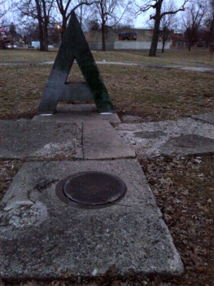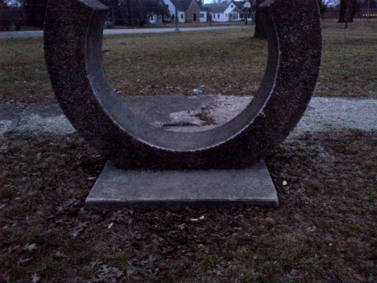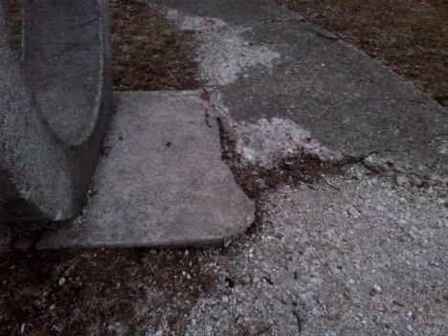
Project Plan:
- Remove the wide crumbling sidewalk that circles the “A” and “C”
- Build a cement pad for the new letter “B”
- Have a new letter “B” made
- Place the new “B” on the new pad
- Back fill the area with soil and plant grass
Goal:
The goal of this project is to correct and complete an obviously incomplete piece of highly visible public art in Westgate Park. With all of the recent and upcoming work in Westgate Park – the renovated shelter houses and recreation center as well as the pond cleaning -- the replacement of the letter “B” is a much-needed improvement for the children’s playground area, for the park, and for the people of the west side who use the park.

