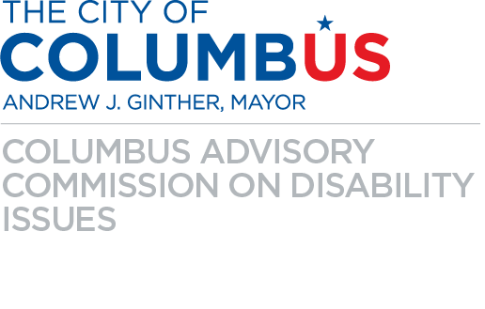

**City of Columbus Parking Garage**

**Conference Room Accessibility Guide**

**Getting There**

* The address for the meeting is 141 North Front Street, Columbus OH 43215 (The City of Columbus Parking Garage).
* We are meeting in the first floor conference room located near the southeast corner of the first floor.
* Driving and Parking
  + If using a GPS, you should put input the following address: 144 North Ludlow Street
    - This address will take you to the garage entrance.
  + There is a gate with security at the parking garage – tell them the reason for your visit to gain entrance.
  + Accessible Parking: Designated accessible parking spaces are available.
* Entry Points: Non-vehicular/pedestrian entrances are accessible from Front Street.
* Wheelchair Access: The garage includes ramps and elevators to accommodate wheelchair users. The elevator can be taken to the first floor and is adjacent to the conference room. When stepping out of the elevator on the first floor, take an immediate left. The doorway to the conference room will be to the left.
* Restrooms: Accessible restrooms are available within the conference room.

**Arriving by Transit**

* The meeting is accessible by transit. You can take Bus Line 4, 7, 9, 10, or 11 to **Bus Stop 8215** (North Front Street & West Long Street). This bus stop has a bench, shelter, and trash can.
* For step-by-step instructions, use the Transit app or print out instructions from COTA’s Trip Planner at [www.cota.com.](https://www.cota.com/)

