Accessibility Guide for CACDI Meetings
Michael B. Coleman Government Center
111 N Front Street, Columbus OH 43215
Getting There
- The address for the meeting is 111 N Front Street, Columbus OH 43215.
- We are meeting in Room 204 on the second floor of the Michael B. Coleman Government Center. To get to the building, follow the directions below:
  - Enter the building through the front door (there is no step up).
  - A security specialist will greet visitors upon entry. You will need to present a valid ID. Once the check-in process is completed, you will receive a visitor sticker badge that must be worn at all times while in the building.
  - You will be asked to move through a metal detector. All belongings must be scanned as well via the x-ray machine.
  - Take the elevator on your right to the second floor where you will find Room 204 across the hall when you exit.
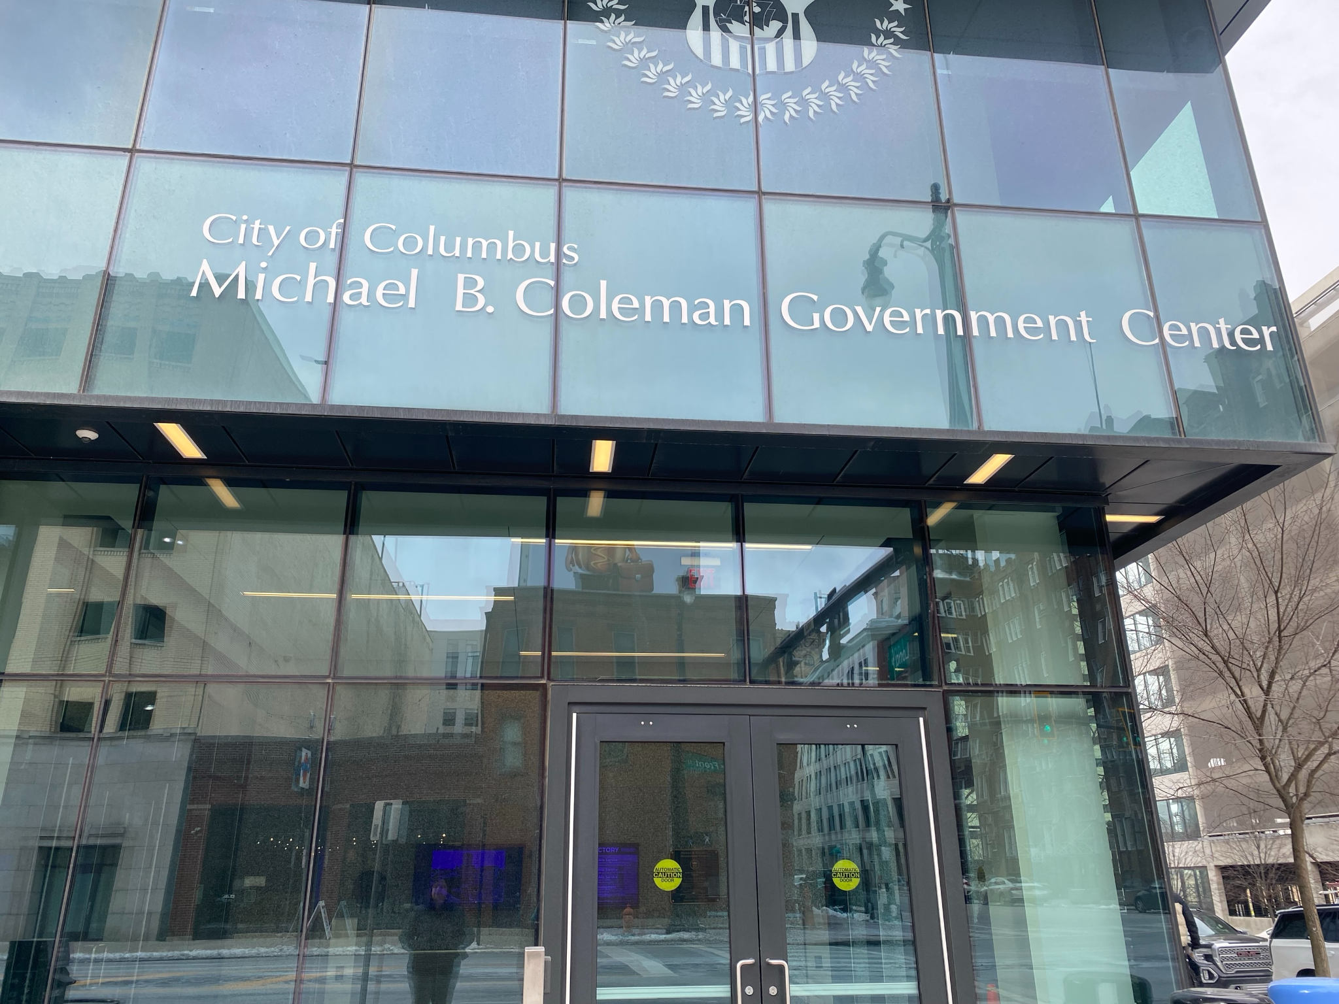
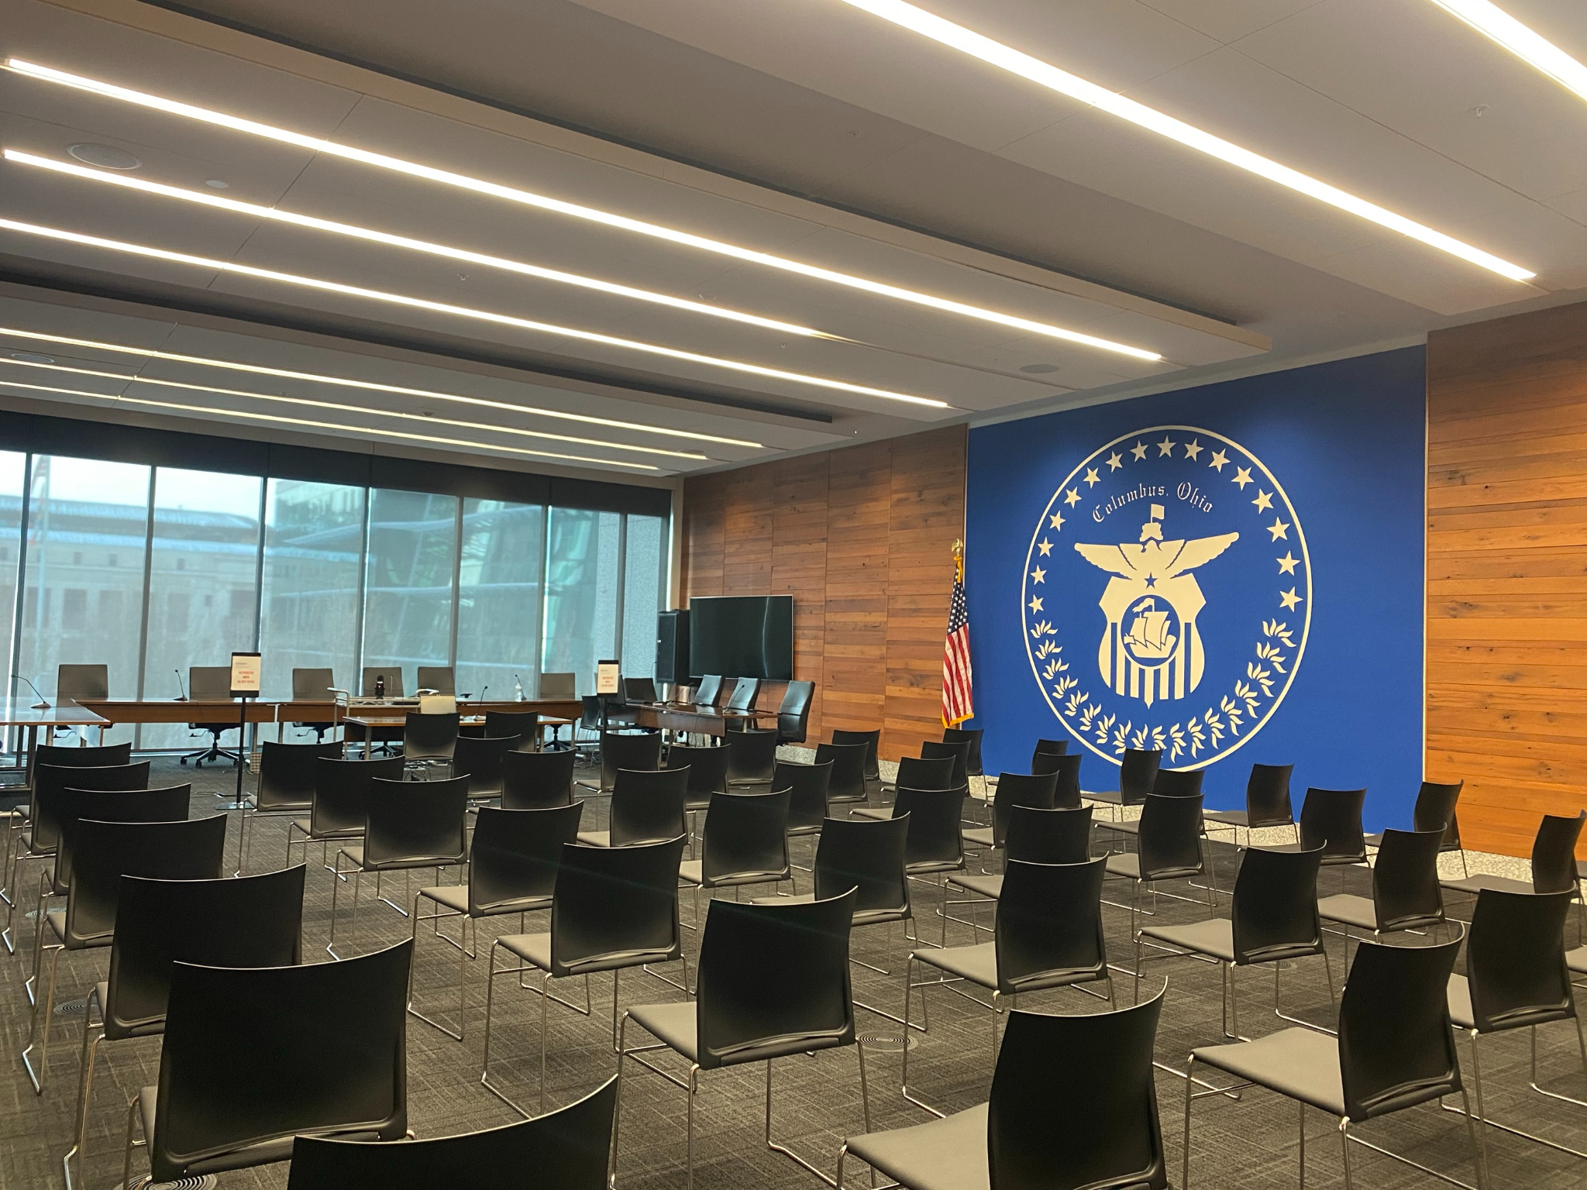

Arriving by Transit
- The meeting is accessible by transit. You can take 4, 7, 9, 10, or 11 to Bus Stop 8215 on N Front Street and Long Street. This bus stop has a bench, shelter, and trash can.
- For step-by-step instructions, use the Transit app or print out instructions from COTA’s Trip Planner at www.cota.com.
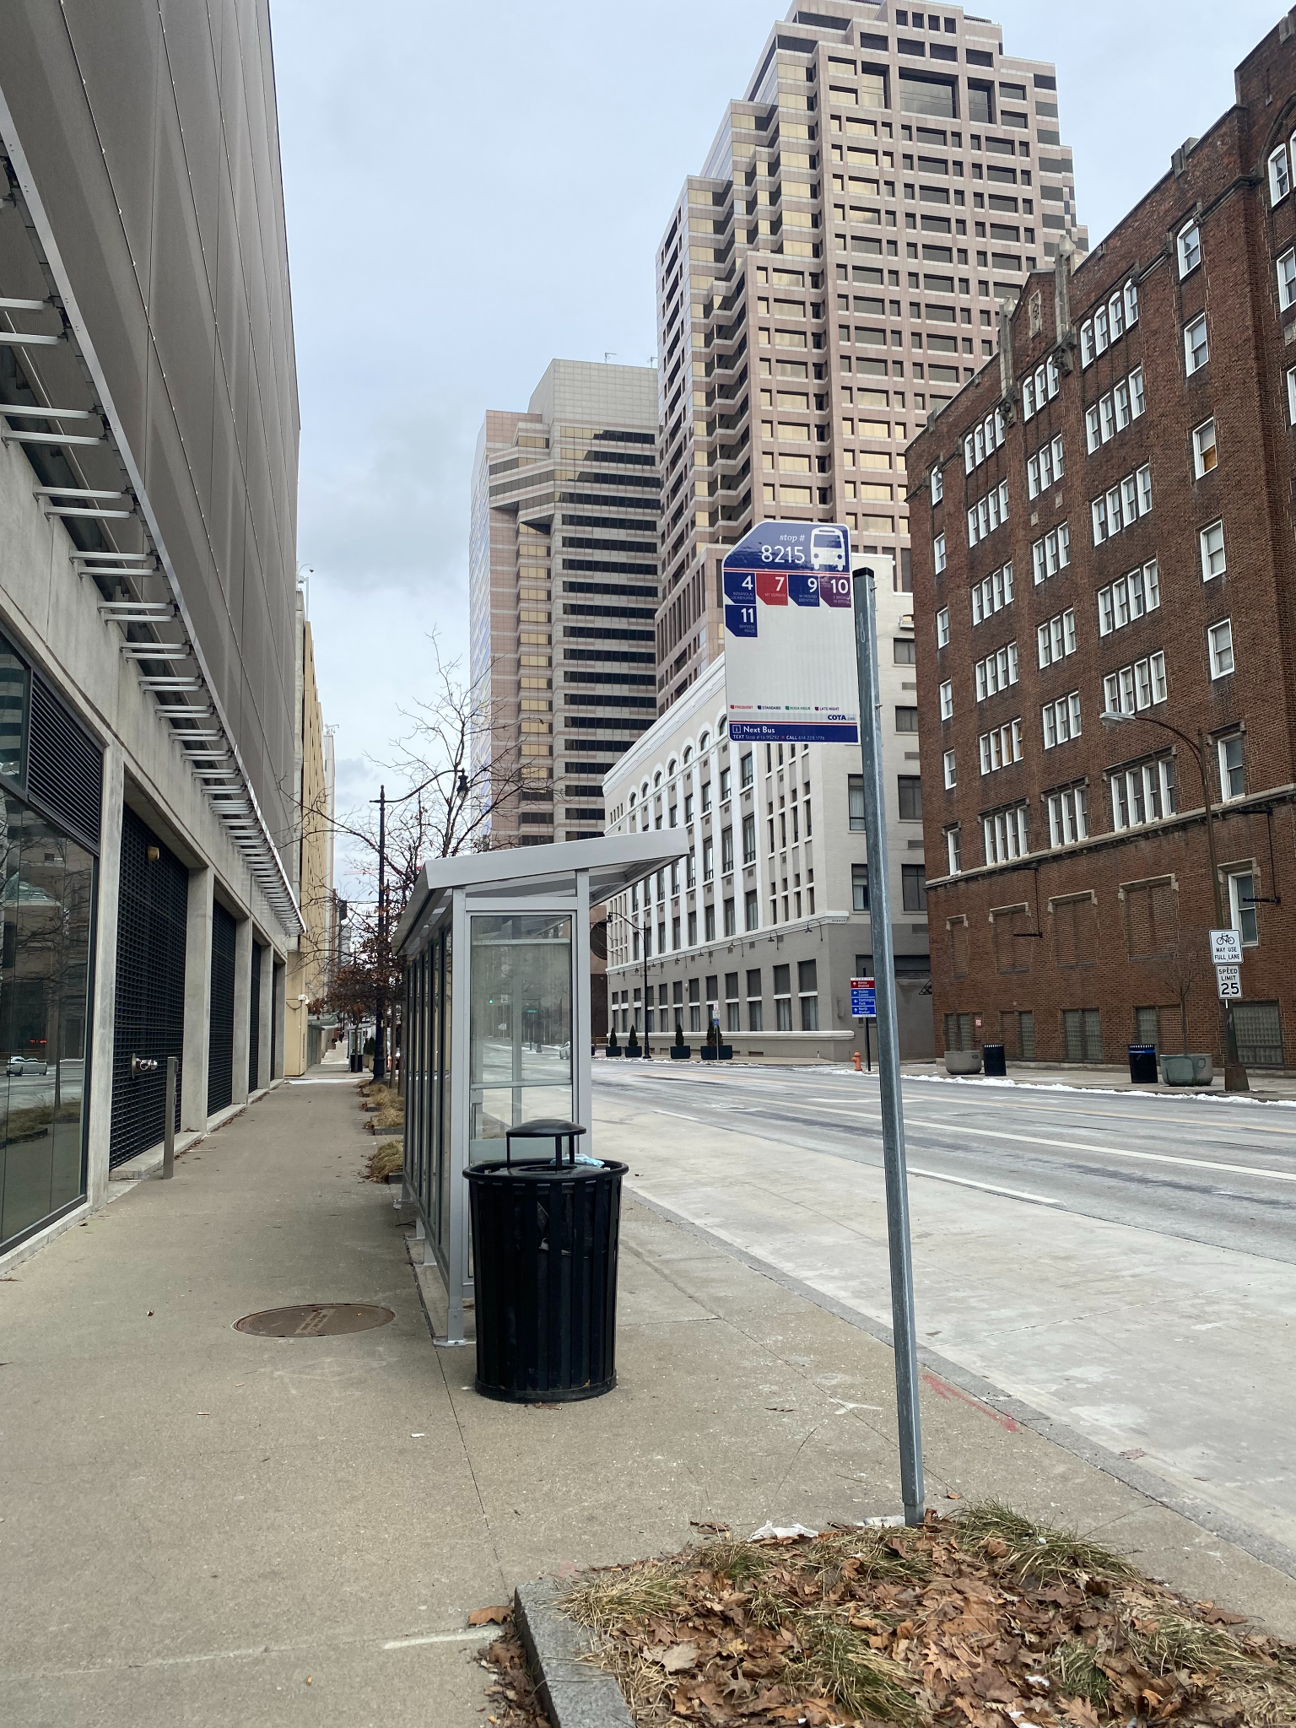

Driving and Parking
- Accessible parking is available for free at 141 N Front Street Parking Garage. If using a GPS, you should put in 144 N Ludlow Street as the address so it takes you to the back of the building.
- There is a gate with security at the parking garage - tell them you are here for the CACDI meeting to gain entrance.
- Take the elevator to the ground floor of the garage and cross the street to the Michael B. Coleman Government Center.

Summary of Accessible Features
- Accessible parking at 1423 N High St, Columbus, OH 43201
- Accessible entrance to the building and to Room 204 (where we will be meeting)
- Accessible restrooms
- Large-print agendas and handouts

