Fire Emergency
The R.A.C.E. Fire Safety Acronym
The R.A.C.E. acronym is a critical tool for remembering how to act in a fire emergency:
- R (Rescue): Immediately get yourself and anyone else in danger away from the fire.
- A (Alarm): Alert everyone in the building by activating the fire alarm and calling the appropriate emergency number.
- C (Confine): Limit the spread of the fire by closing doors and windows behind you as you leave.
- E (Extinguish/Evacuate): Attempt to extinguish the fire only if you are trained and it is safe to do so; otherwise, evacuate the building to a safe location

Fire Alarm Activation
If You See or Hear the Fire Alarm Sounding
Begin EVACUATING the building using the Exit Stairs (NEVER USE THE ELEVATOR, unless it is under the direct control of the Fire Department).
Close doors behind you (if possible)
Proceed to the DESIGNATED area of safe refuge ONLY if you are unable to safely evacuate the building.
If you are unable to evacuate, please follow the Shelter in Place guidelines below

If you see SMOKE, FLAMES, or SMELL something Burning- IMMEDIATELY:
ISOLATE the fire by closing the door, if possible.
ACTIVATE the FIRE ALARM PULL STATION
EVACUATE the building using the Exit Stairs (NEVER USE THE ELEVATOR, unless it is under the direct control of the Fire Department).
Proceed to the DESIGNATED area of safe refuge ONLY if you are unable to safely evacuate the building.
Call 911

Elevator Use During a Fire Emergency
There are a few reasons why it is not safe to use an elevator during a fire. An elevator shaft provides a natural chimney. As such it can quickly fill with smoke. The policy of this building is that all able-bodied people shall exit the structure via the stairwell in the event of a fire or fire alarm activation or other emergency situations.
IN CASE OF FIRE/FIRE ALARM ACTIVATION USE STAIRWAYS ONLY
DO NOT USE THE ELEVATOR

Special Instructions for Mobility or Physically Impaired Occupants
People having any physical or mobility impairment need to be considered prior to any need for evacuation. It is necessary for staff to know of any mobility or physically impaired tenants who may require special assistance in the event of an evacuation.
During a fire alarm activation if there is evidence of fire, persons having physical/mobility impairment should be instructed to stay in their room and shelter-in-place.
Occupants who shelter in place should use a voice communication system (telephone or other similar device) to contact emergency services (via 9-1-1) if they are sheltering in place and the emergency is located near where they are sheltering
Shelter-in-Place
There may be circumstances when sheltering-in-place is advised. This can be for several reasons, emergencies in surrounding buildings, on public streets, or emergencies in other suites within the building. In many cases, sheltering may be advised by first responders.
If residents and visitors are unable to evacuate the building because of fire/smoke conditions or a physical mobility issue, please shelter-in-place.
Position the Shelter in Place signage in your window facing outwards. After the alarm has been resolved, remove the Shelter in Place signage from your window and store in an easily accessible location.
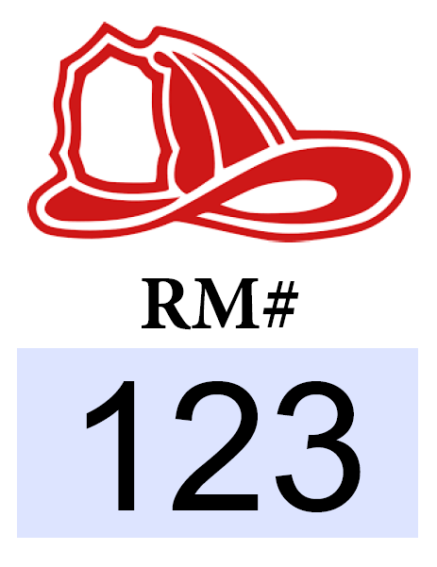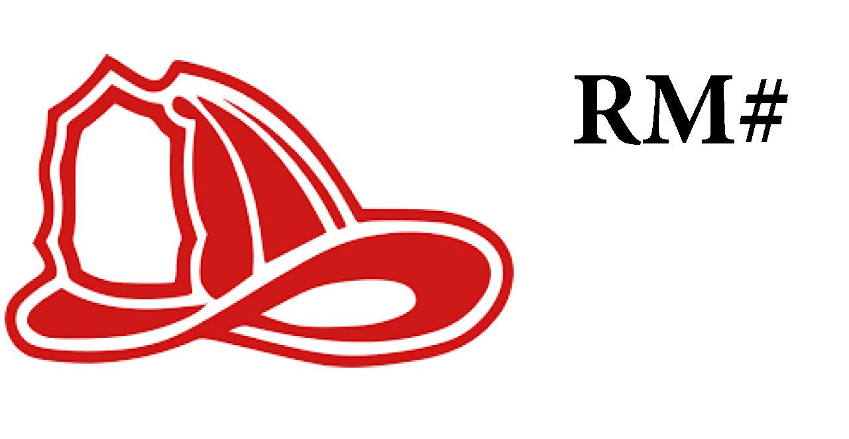

Outside Assembly Meeting Location
During a fire emergency, fire alarm activation, or other situations in which a full or partial building evacuation is required. We have identified outside meeting locations where residents should report to when evacuating the building.
There are/is _____________ assembly areas assigned for this building based upon your location within the building at the time of the emergency evacuation.
Please report any missing individuals to emergency responders immediately and let them know what floor the person{s) were last seen.

Severe Weather
The National Weather Service reports the movement of severe weather that may present a threat to the Columbus metropolitan areas. Severe weather includes, but is not limited to: thunderstorms, tornados, windstorms, etc.
If a tornado warning is issued by the National Weather Service:
Relocate to the building's ______________________________ until the weather emergency passes.
- Whenever possible, designate areas which are located below ground level, in the core of the building, in rooms or spaces with short ceiling spans, and on the leeward side. The farther the area is below ground level, the greater the protection. In any event, the area should be on the lowest floor, in the center of the building, and in a corridor or small room.
- Avoid walls of glass, windows, skylights, and areas containing trophy cases or other fixtures of glass.
- Avoid load-bearing walls and exterior walls, especially those on the windward side or facing the south, southwest, or west.
The National Weather Service recognizes the following conditions:
- Tornado Watch: Be Prepared! Tornadoes are possible in and near the watch area. Review and discuss your emergency plans, take inventory of your supplies and check your safe room. Be ready to act quickly if a warning is issued or you suspect a tornado is approaching. Acting early helps to save lives! Watches are issued by the Storm Prediction Center for counties where tornadoes may occur. The watch area is typically large, covering numerous counties or even states.

- Tornado Warning: Take Action! A tornado has been sighted or indicated by weather radar. There is imminent danger to life and property. Move to an interior room on the lowest floor of a sturdy building. Avoid windows. If in a mobile home, a vehicle, or outdoors, move to the closest substantial shelter and protect yourself from flying debris. Warnings are issued by your local forecast office. Warnings typically encompass a much smaller area (around the size of a city or small county) that may be impacted by a tornado identified by a forecaster on radar or by a trained spotter/law enforcement who is watching the storm.
- Tornado Emergency: Seek Shelter Immediately! A tornado emergency is the National Weather Service’s highest alert level. It is issued when a violent tornado has touched down in the watch area. There is a severe threat to human life and property, with catastrophic damage confirmed. Immediately seek refuge in the safest location possible. Call friends and family who are within the watch area to ensure they are aware of the situation. If you see a tornado approaching, do not attempt to outrun it in a vehicle; shelter in place. Once safe, be sure to monitor your local forecast for the latest updates.

Gas Leak
Immediate actions (inside the building)
- Evacuate: Get everyone out of the building immediately.
- Do not use electrical devices: Do not turn on or off any lights, appliances, or use cell phones.
- Do not create sparks: Do not smoke, use matches, or operate anything that could cause a spark.
- Do not try to find or stop the leak: Do not attempt to locate the leak, operate valves, or make repairs.
Actions after evacuation
- Call for help: From a safe distance, call 911 and the local natural gas company. The utility company's number should be on the nearest pipeline marker or your gas bill.
- Warn others: Keep others from entering the area and warn them of the danger.
- If ignited, let it burn: If the gas has already ignited, do not attempt to extinguish the fire. Move to a safe distance and let it burn while you wait for emergency responders.
- Do not start vehicles: Avoid starting any vehicles near the leak.

Power Failure
In the event the building sustains a power failure, the building’s generator will automatically turn on.
Generally, heating, ventilation and air conditioning (HVAC) equipment, lights, outlets, most elevators and telephone equipment will be operational; however, check with the property team to become familiar with the systems that are in place at your building.
- The property management will contact American Electric Power (AEP) to attempt to find out the cause of the outage and the anticipated duration of the outage.
- Turn off all appliances, computers and other equipment. If equipment is turned on and a power surge occurs, the surge may damage the equipment.
- Determine if any people are trapped in the elevators. If so, ask the occupants to remain calm and determine if anyone is injured. Advise them that you are requesting assistance. Remind the occupants the elevator cars contain emergency phones. People outside the elevator cars should also call 9-1-1 to report the elevator entrapment as well.
- Call 9-1-1 if people are injured or in danger.
- Contact Property Management and inform them of entrapment, status and location of the elevator car. Have someone stay in contact with the trapped individuals until assistance arrives.
If the power outage becomes lengthy (an hour or more) and the electric company does not know how long the power will be out, the property team will provide information and direction to the tenants. The building may close for business.

Medical Emergency
Use this procedure in case of a medical emergency. This could be for a tenant, occupant or visitor.
- Have a person trained in first aid check the patient to see if outside medical assistance is needed. If patient has any difficulty breathing, chest pain, and altered consciousness or is unconscious don’t waste time, call 9-1-1, know location of AED system and train personnel with a backup AED.
- Give all necessary information:
a. Address
b. Floor
c. Room
d. Condition
e. Number of patients
- Have somebody meet the Fire/EMS crew at ground level and also on the floor of the emergency.

