FOR IMMEDIATE RELEASE 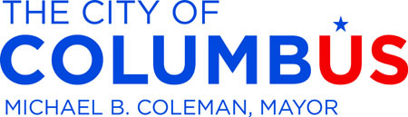
November 23, 2014
Contact
Dan Williamson, Mayor’s Office, 645-5300
Cynthia Rickman, Development Department, 645-8795
John Ivanic, City Council, 645-6798
Web – Facebook – Twitter

FOR IMMEDIATE RELEASE
November 20, 2014
Three Columbus Businesses to Benefit from Green Incentives
City grants totaling more than $200,000 will aid two brownfield projects and a green building project. Mayor Michael B. Coleman is asking City Council to approve legislation for the projects, which includes a brownfield grant that will be used to clean up a former downtown department store that has been vacant and blighted for more than two decades.
“We created the Green Columbus Fund so that we could set aside resources to make our city greener and cleaner,” Mayor Coleman said. “We’re excited about the positive change these projects will create Downtown and throughout Columbus.”
The City will provide a grant for $135,990 to the Day Companies for the redevelopment of three commercial properties on North High Street, which includes the former Madison’s Department Store.
The company plans to redevelop the site with a mix of office, residential, retail, parking and hotel.
“I look forward to the Day Companies doing what the previous owner was unable or unwilling to do,” said Michelle M. Mills, chair of the Development and Environment Committees. “We are grateful that the new owner hopes to develop the site in a safe manner that positively impacts the commercial and residential mix downtown.”
The Franklinton Development Corporation continues its redevelopment efforts at 421-435 W. State Street and will receive a grant of $55,000 for Brownfield assessment and redevelopment. Columbus engineering firm Advanced Engineering Consultants, will enter into a LEED Certified green building agreement for $10,500 to renovate its offices at 1405 Dublin Road.
Funds for the Brownfield component of the program are capped at $200,000 per project. The basic elements of the program and where to go for details and applications are available online at www.GetGreenColumbus.org.
_ _ _

