FOR IMMEDIATE RELEASE 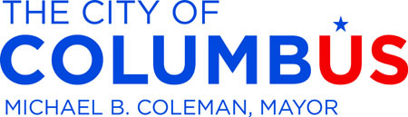
December 3, 2014
Contact: Erin Miller, Mayor’s Office, 645-0815

Communitywide Five-Year Sustainability Plan
Released for Final Comment and Review
The Mayor’s Office of Environmental Stewardship is seeking public review and feedback of the next five-year sustainability plan. The plan can be reviewed and comments submitted until December 17 online at www.Columbus.gov/SpeakUp.
“For the first time, this plan is not just an internal city document,” said Mayor Michael B. Coleman. “It was crafted for the community, by the community because it will take all of us working together to fully realize our vision for a green community that is beautiful, healthy and prosperous.”
For the past year, the Mayor’s Office of Environmental Stewardship has been crafting the plan with the help of the community. Ideas were solicited for the plan at events, focus groups and via online survey. The Mayor’s Green Team developed the plan’s vision statement, focus areas and prioritized action items.
“Columbus is a national leader in environmental stewardship and sustainability,” said Councilmember Michelle M. Mills, chair of the Environment Committee. “By continuing to work together on initiatives like the five-year plan, we can create a greener, healthier community.”
Mayor Michael B. Coleman released the city’s first five-year plan for sustainability in 2005 to strategically reduce the impact of city operations on the environment. In 2010, a follow-up plan was released. The initiative’s most notable accomplishments include the development of the popular residential recycling service, removal of the Fifth Avenue low head dam and subsequent river restoration, installation of a large-scale solar array, conversion of city fleet to cleaner burning fuels and launch of CoGo Bike Share.
“Mayor Coleman has elevated the environment as an issue of top importance,” said Aparna Dial, Director of Sustainability at The Ohio State University and Chair of the Mayor’s Green Team. “As a result, environmental protection is a core value of our community and we are all invested in seeing that the actions spelled out in this plan come to fruition.”

The final version of the document is scheduled to be released at the Columbus Metropolitan Club on January 9.

-30-

