we are

EVENT LOGO HERE

committed.

Careful and deliberate steps have been taken throughout the event planning process to reduce environmental impact of FESTIVAL NAME and support sustainability, which is a core value of the Columbus community.

We need your help to fulfill this commitment and ask that you follow the guidelines below:

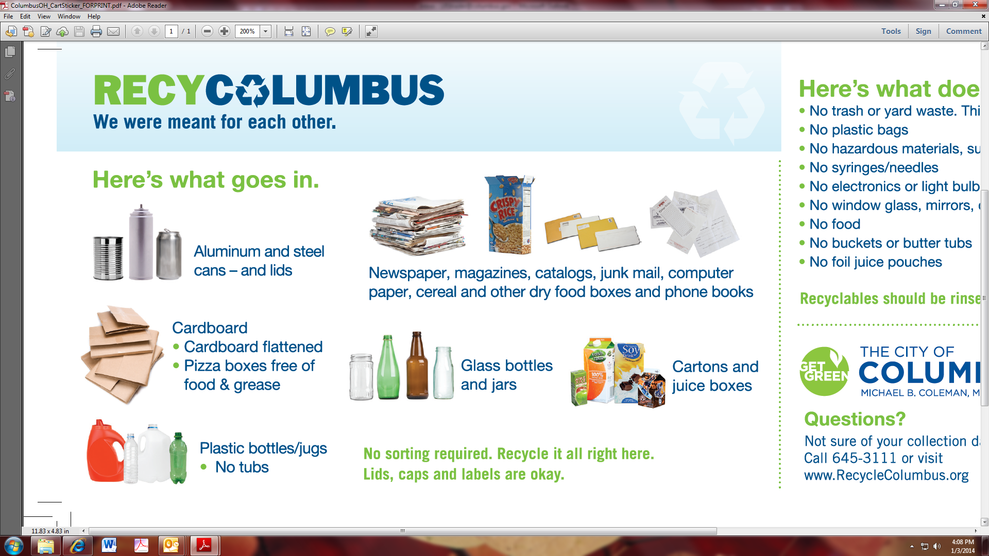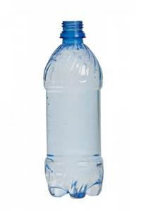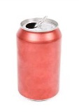

ACCEPTED RECYCLABLES

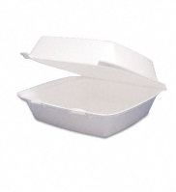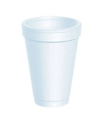

**Carefully select food service containers.**

Serve food items in reusable or recyclable containers.

Avoid use of plastic cups, clam shells and cutlery, polystyrene- “Sytrofoam” and other materials that cannot be recycled in Columbus.

**Recycle.**

Collection will be provided for cardboard boxes, plastic and glass bottles, jugs and jars and other recyclable items. Use this service and do your part to avoid putting recyclables into containers designated for trash only.

NOT RECYCLABLE



**Avoid idling your vehicle or running a generator to reduce air pollution.**

Emissions from a car, truck or generator negatively impacts guest experience and is a contributor to air pollution. Limit time spent idling as much as is possible.

**Reduce giveaway items and print materials.**

REUSABLE GIVEAWAYS

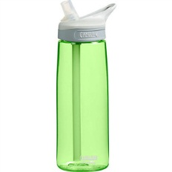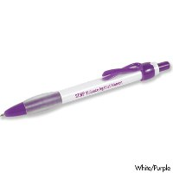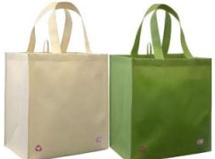

Limit the amount of promotional items and print materials you give away. These often become litter or are thrown away at home. If you want to provide a promotional item, please take steps to ensure it has a lasting purpose such as a reusable water bottle, grocery bag, etc.